Họ tên : Lê Bá Khánh Trình

MSSV : 6151071108

Lớp : CNTT-K61

1. Write a PL/SQL block to learn how to declare a character type variable.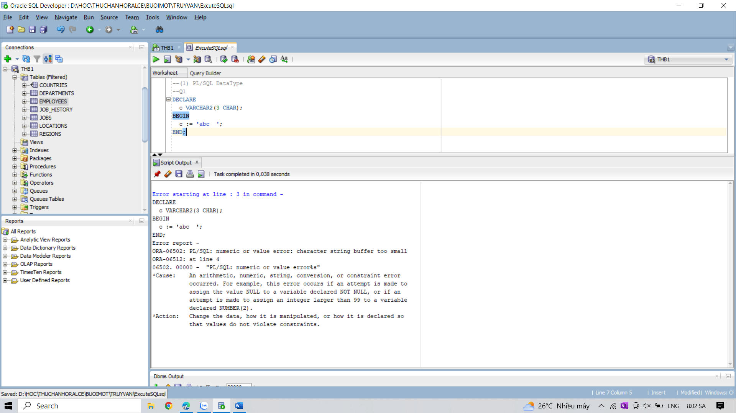

2. Write a PL/SQL block to insert data to a table using character type variable.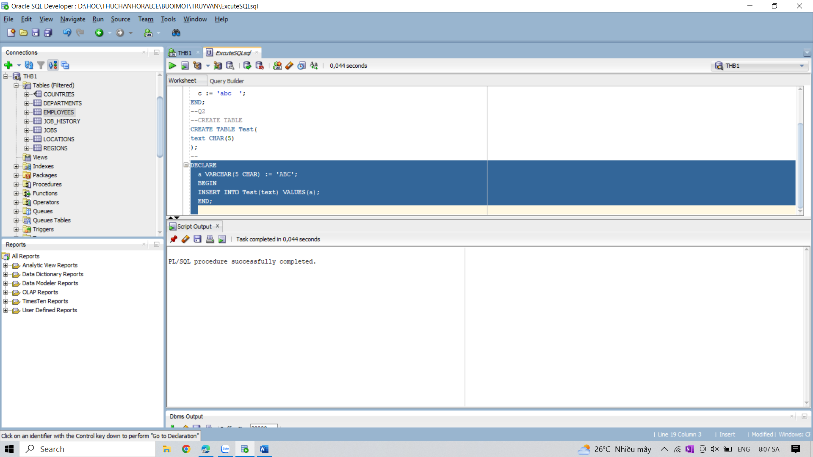

3. Write a PL/SQL block to differenciate between CHAR and VARCHAR2 datatype.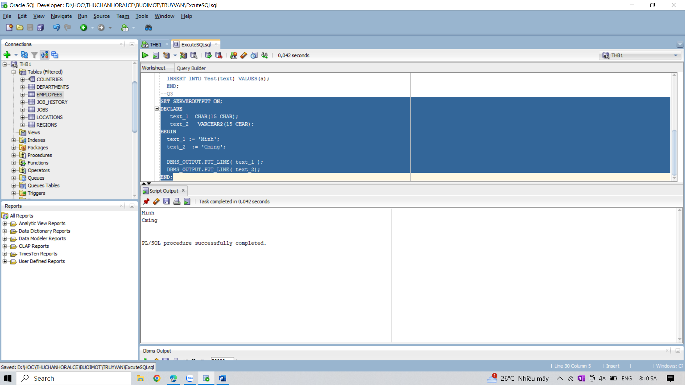

4. Write a PL/SQL procedure to accepts a BOOLEAN parameter and uses a CASE statement to

print Unknown if the value of the parameter is NULL, Yes if it is TRUE, and No if it is FALSE.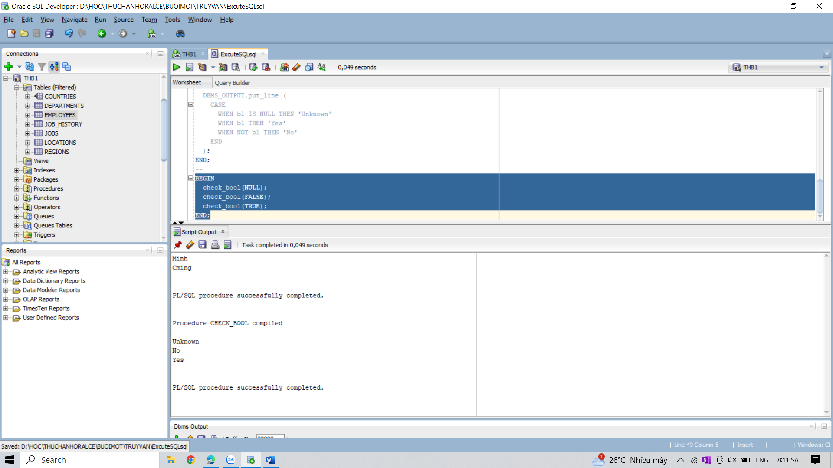

5. Write a PL/SQL program to show the upper limit of PLS_INTEGER.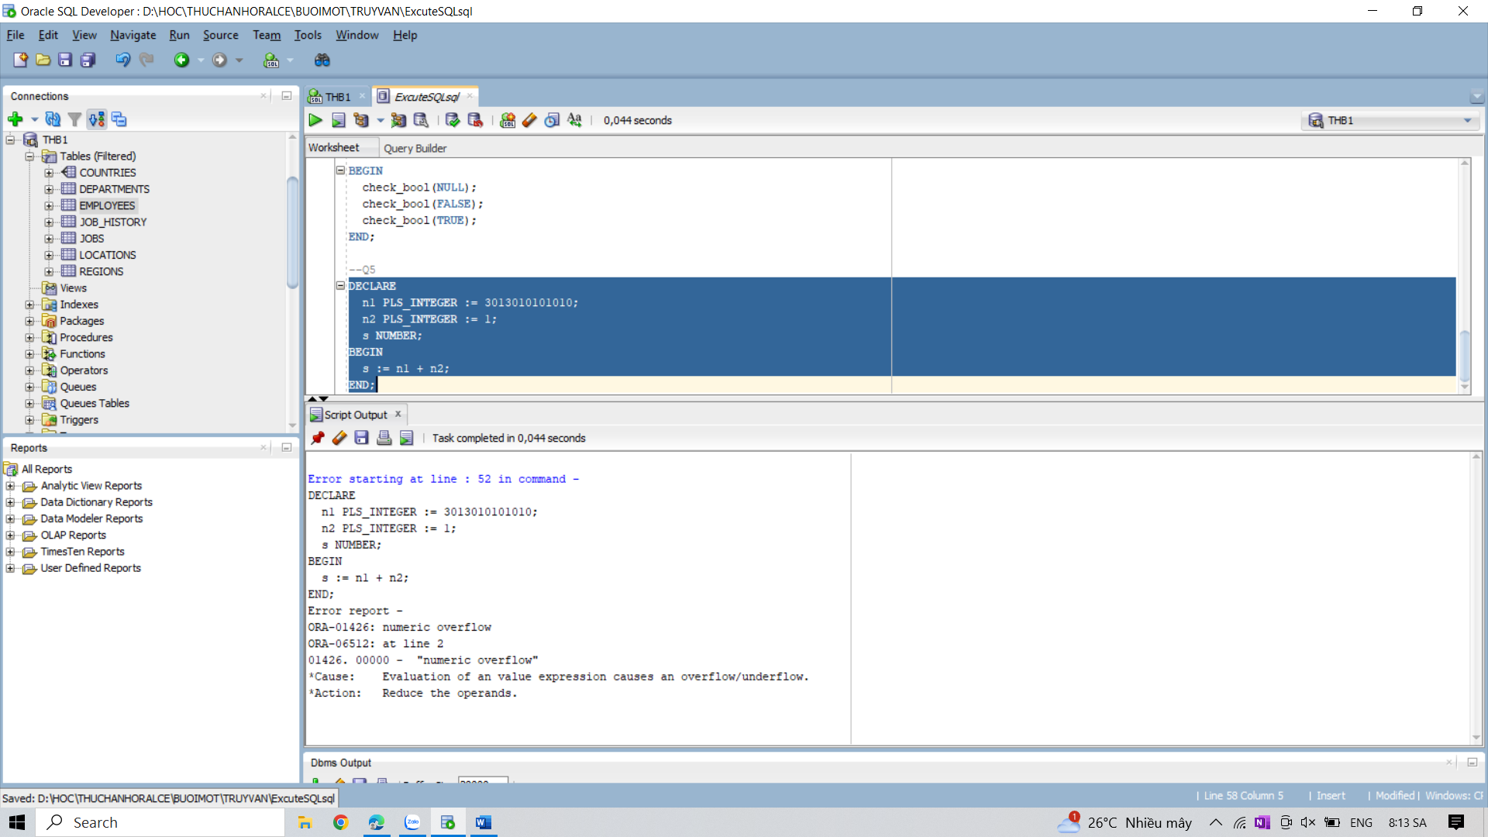

6. Write a PL/SQL program to show the uses of SIMPLE_INTEGER datatype.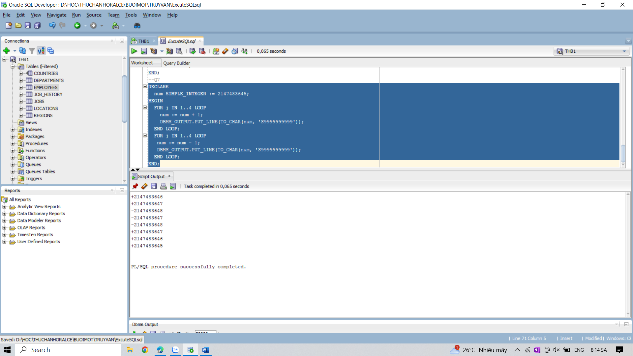

7. Write a PL/SQL program to show the uses of an unconstrained subtype, i.e., the same set of

values as its base type.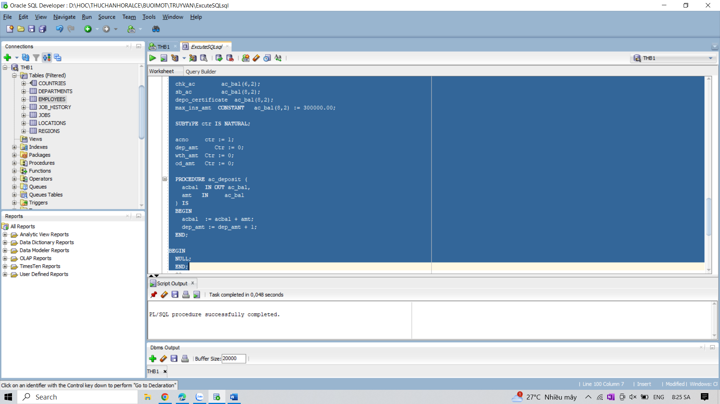

8. Write a PL/SQL program to show the uses of a constrained subtype.